security report: steganography
28430093 – Alwyn Barnard – ITRW 316 2019

Table of Contents
Introduction 2
How does it work? 2
Malicious use of Steganographic Techniques 3
Steganographic Technique: Least Significant Bit Steganography 4
Summary 4
References 5

Introduction

Steganography is an encryption technique that hides data within data. This is used alongside cryptography to hide sensitive encrypted data in any media file of your choosing (Techopedia inc., 2019).
Steganography comes from the Greek words staganos, meaning hidden or covered, and graph, meaning to write. With Steganography you can hide almost anything in any type of digital content like text, image, video or audio (Rouse et al., 2018).

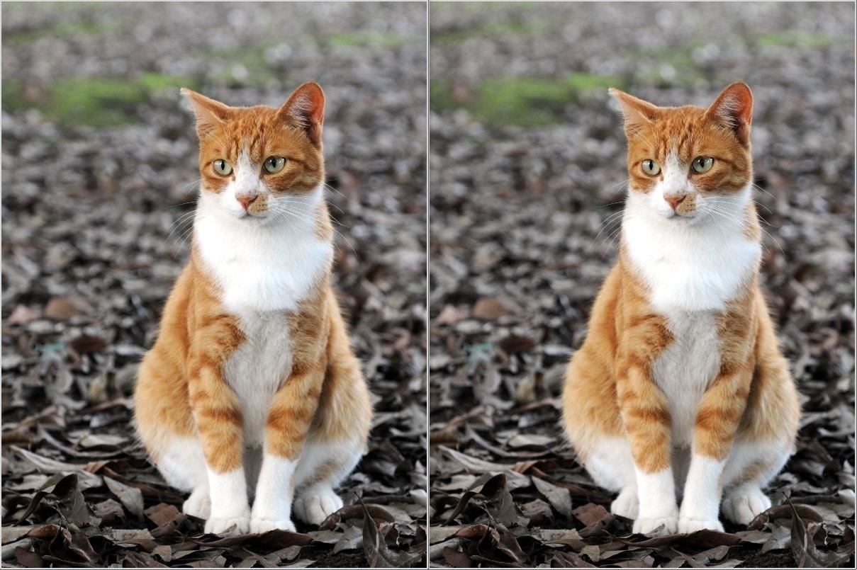
Pictured below on the left is a normal picture of a cat, and on the right is the same picture that was merged with a text file filled with names, surnames, phone numbers and email addresses (Black Slash, 2018)

How does it work?
In modern steganography techniques, data is encrypted for an extra layer of security, and then inserted using a specialised algorithm. This data (called the hidden text) is inserted into a particular file (called the cover text file). One technique to do this is to hide the data in the bits that represents the same colour pixels repeated in a row in an image. By doing this, you will have an image that looks identical to the original image but with patches of data containing “noise” or encrypted data.

Another technique is called Watermarking. Here, a trademark or identifying piece of data is inserted into the media file to identify the source of media files that were shared without permission.

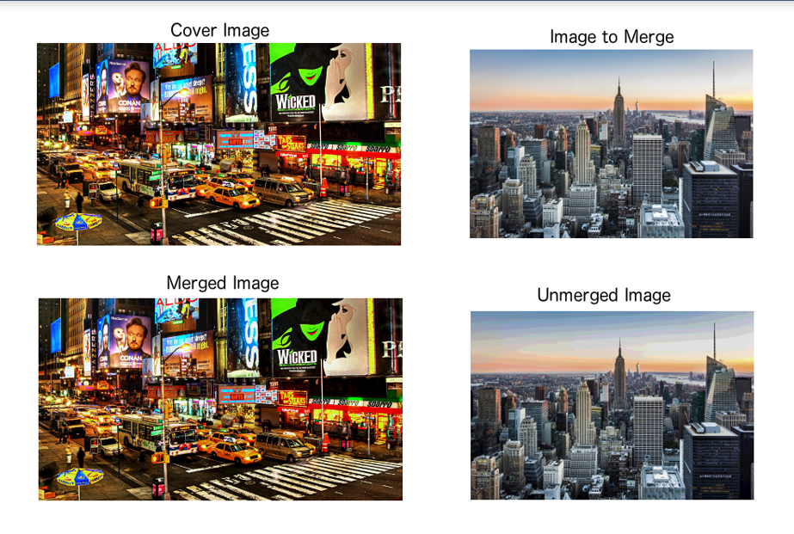

Malicious use of Steganographic Techniques


A popular security firm called Trend Micro, reported that a meme made up of the 1999 film “The Matrix” was used to send remote controlled instructions to computers infected with a virus called the Berbomthum virus (Schwartz, 2018). See below:

Steganographic Technique: Least Significant Bit Steganography
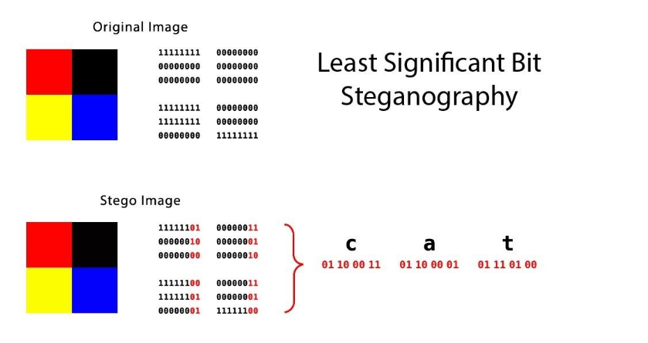
This technique takes the image’s colour breakup and changes the last few bits of in a byte to encode a message into it, which produces the exact same image but with a slightly softer colour tone which is undetectable to the human eye. In the above image, the word cat was inserted into the image and the result was the colour red was changed from RGB 255 to RGB 253.

Summary
Steganography is a data encryption tool that hides important data between the gaps of redundant data or that uses redundant data and changes it slightly to hide a message or file from someone. In the past it has been mostly used in a malicious context but can also be used by reporters or investigators if they need to send data whilst in hostile countries away from prying eyes.

References
Rouse, M., Neijts, R., Semilof, M. & Clark, C. 2018. What is staganography. Definition by whatis.com http://whatis.techtarget.com/definition/steganography/ Date of access: 21 May. 2019.

Schwartz, M. J. 2018. The rise of self-concealing steganography. https://www.bankinfosecurity.com/webinars/webinar-future-adaptive-authentication-in-financial-services-w-1885?rf=promotional_webinar Date of access: 21 May. 2019

Technopedia incorporated. 2019. Steganography. http://www.techopedia.com/dictionary/tags/security/steganography/ Date of access: 21 May. 2019

WonderHowTo.com & Black Slash. 2018. How to hide secret data inside an image or audio file in seconds. http://null-byte,wonderhowto.com/how-to/steganography-hide-secret-data-inside-image-audio-file-seconds-0180936/ Date of access: 21 May. 2019.

